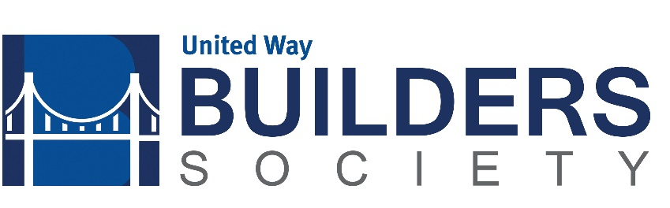

Payment Schedule for 2018 Pledge
Year you make Year you pay Amount Amount of Total Gift
your pledge your pledge you pay match
2018 2019 $2,500 $2,500 $5,000
2019 2020 $3,750 $1,250 $5,000
2020 2021 $5,000 $0 $5,000

I (we) make this 3 year commitment to improve lives and community conditions by becoming members of the Builder Society as detailed above.

- Name: Click here to enter text. Date: Click here to enter a date.
- The membership shall be in the name of: Click here to enter text.
- Email address: Click here to enter text.
- Amount: Click here to enter text.
- Payment:
Employer Name
(check enclosed)
Click here to enter text. Account number
Billing Options
I intend to request funds through Donor Advised Fund
This is not a pledge

- Employer Name: Employer Name
- Special Donor Notes Special Donor Notes
Please contact Kate Roy at 458-2033 if you have any questions or return to United Way of Central Alabama Builders Society, P.O. Box 320189, Birmingham, AL 35232 or kroy@uwca.org.

