Stephens Circle
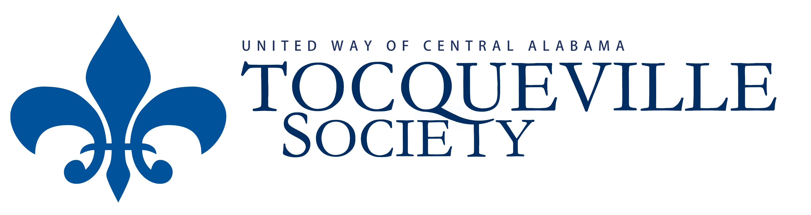
Payment Schedule for 2018 Pledge

Year you make Year you pay Amount Amount of Total Gift
your pledge your pledge you pay match
2018 2019 $12,500 $2,500 $15,000
2019 2020 $15,000 $0 $10,000

I (we) make this 2 year commitment to improve lives and community conditions by becoming members of the Tocqueville Society with commitment to payment outlined above.
- Name: Click here to enter text. Date: Click here to enter a date.
- The membership shall be in the name of: Click here to enter text.
- Email address: Click here to enter text.
- Amount: Click here to enter text.
- Payment:
Employer Name
(check enclosed)
Click here to enter text. Account number
Billing Options
I intend to request funds through Donor Advised Fund
This is not a pledge
- Employer Name: Employer Name
- Special Donor Notes Special Donor Notes

