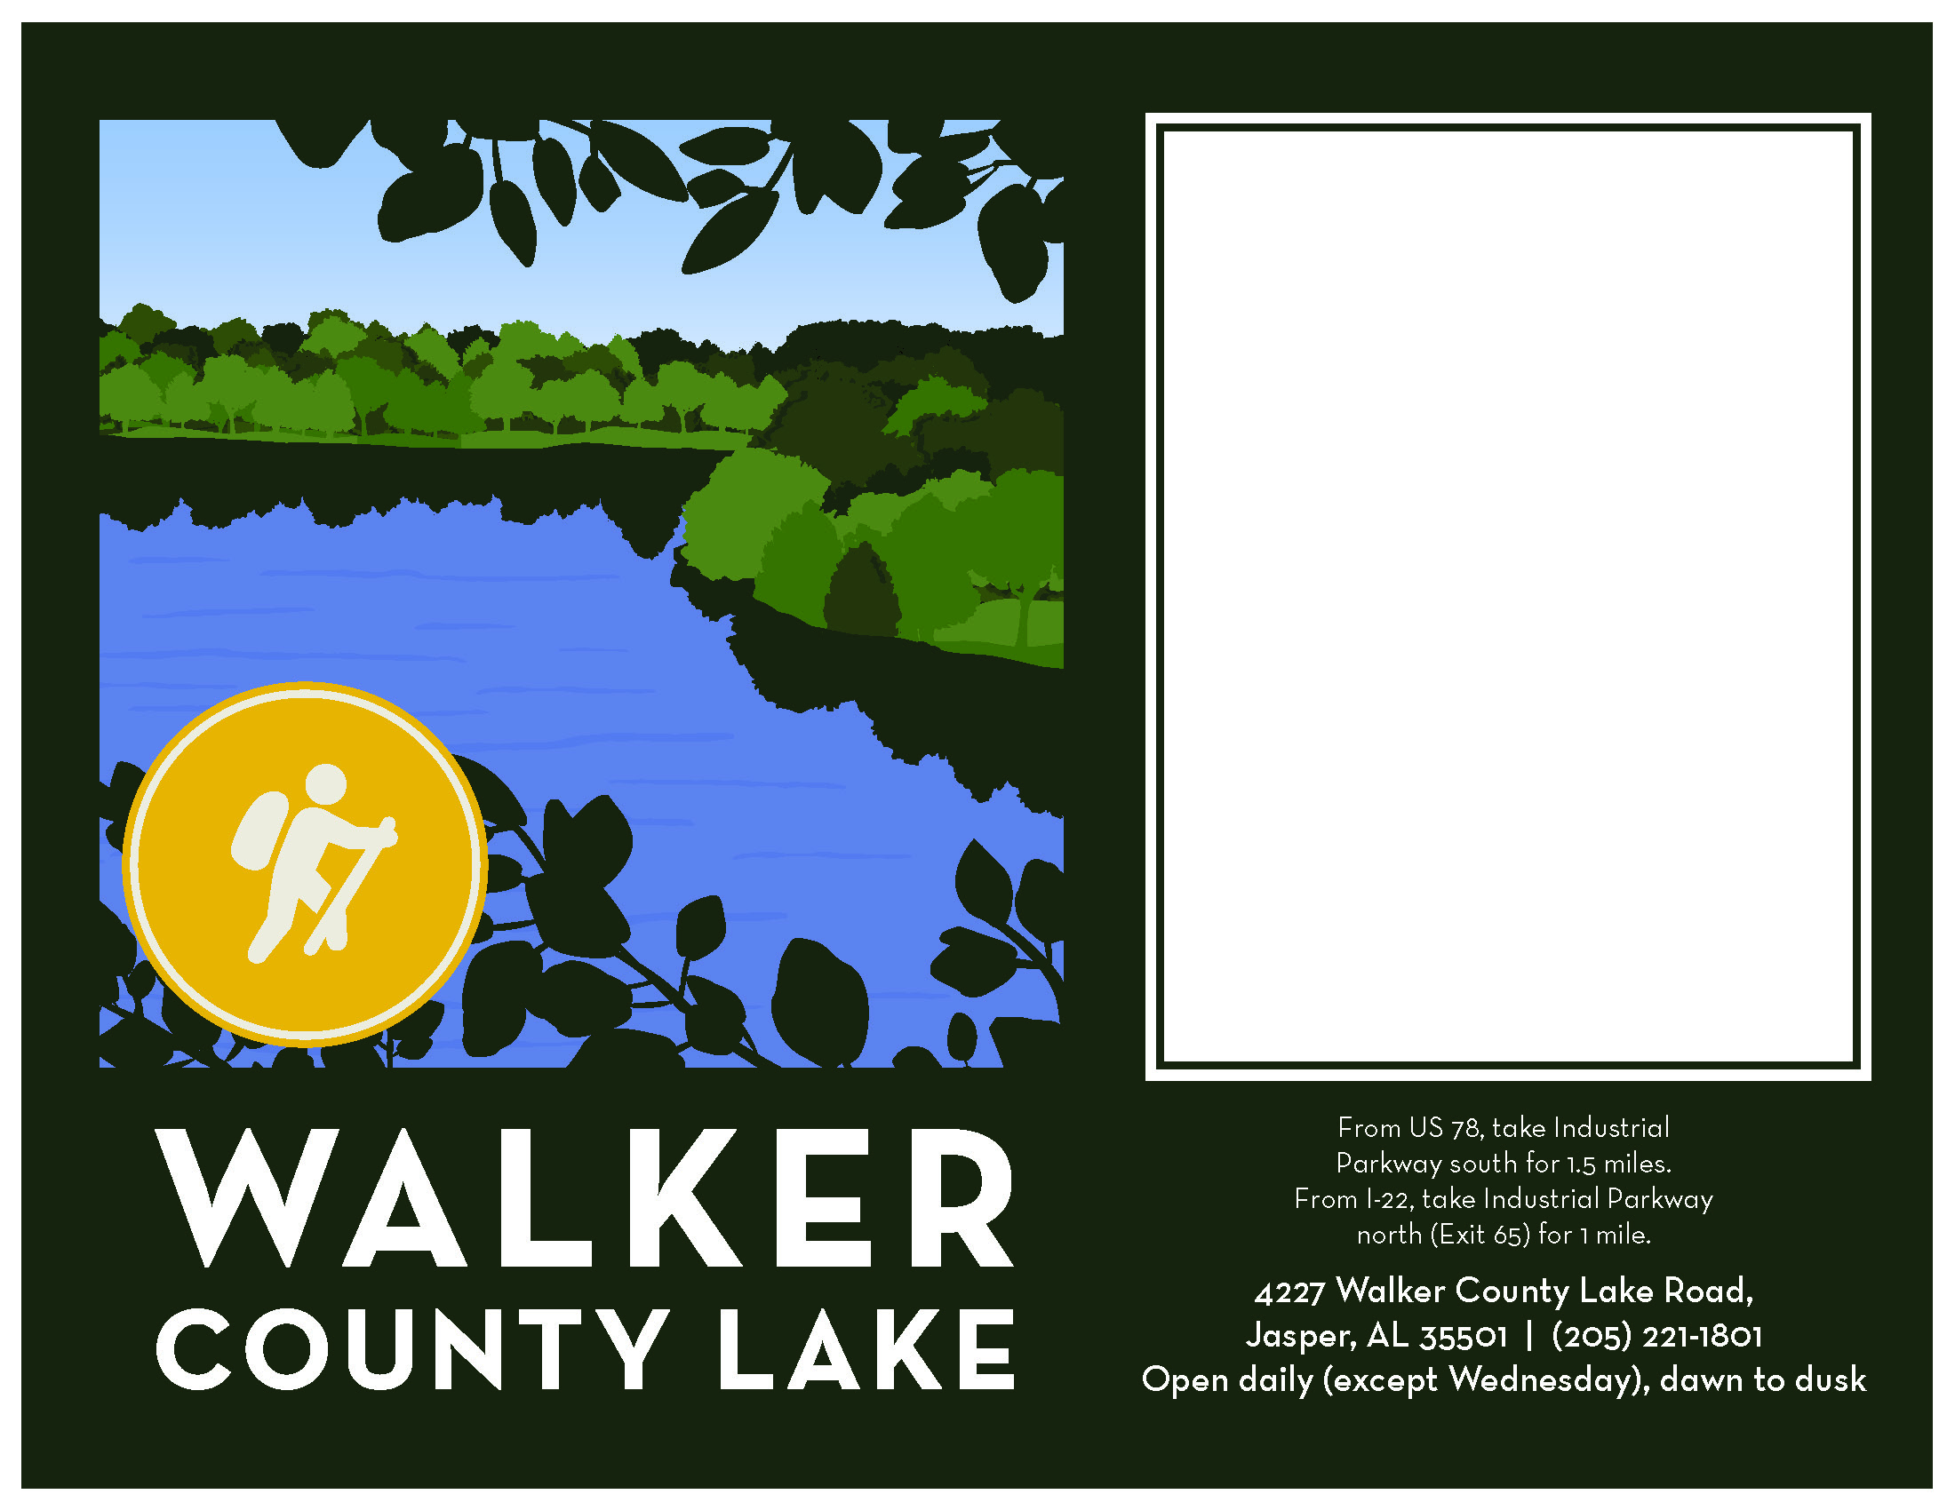

Any text can go in here

It’ll depend on the fonts you have and how much information you have to convey.

Event Name

Event description & information

**Date & Time of event**

**Meeting location**

Questions?

Call _____ at 205-555-5555

Or email at ____