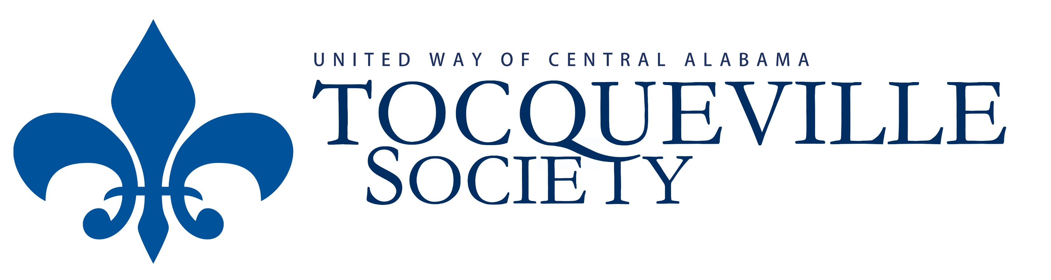
Meyer Match
Tocqueville Society ($10,000 to $14,999)

Year you make Year you pay Amount Amount of Total Gift
your pledge your pledge you pay match
2020 2021 $5,000 $5,000 $10,000
2021 2022 $7,500 $2,500 $10,000
2022 2023 $10,000 $0 $10,000

I (we) make this 3 year commitment to improve lives and community conditions by becoming members of the Tocqueville Society with commitment to payment outlined above.
- Name: Click here to enter text. Date: Click here to enter a date.
- The membership shall be in the name of: Click here to enter text.
- Email address: Click here to enter text.
- Amount: Click here to enter text.
- Payment:
Employer Name
(check enclosed)
Click here to enter text. Account number
Preferred month/date: _________________
I intend to request funds through Donor Advised Fund
This is not a pledge
- Employer Name: Employer Name
- Special Donor Notes Special Donor Notes

