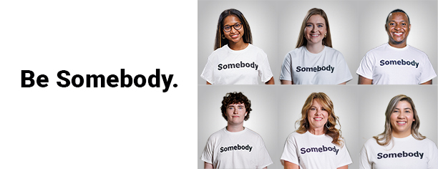
[Name],
Every child in Central Alabama deserves a chance to learn. Every person should have enough to eat. And every family should have access to mental health support if they need it. These may seem like basics, but the fact is, they’re needs that are often unmet.
Somebody needs to help.
That’s why we’re partnering with United Way of Central Alabama. When you support United Way, you are Somebody who’s part of the solution, because United Way provides services that change lives throughout our community every day.
You will soon receive an email announcing United Way of Central Alabama’s annual campaign. Your gift will directly impact hunger relief, mental health, education, crisis response and more. United Way provides immediate access to services today, while also addressing long-term solutions for our future.
It’s through the combined support of every person – every Somebody out there – that United Way helps so many people in so many ways. We’re asking you to join us and Be Somebody.

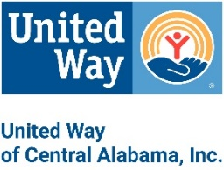
[Name]
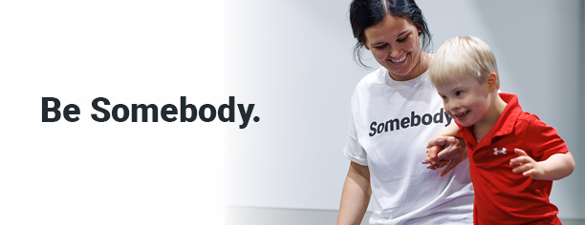

[Name],
Today we’re kicking off United Way of Central Alabama’s (UWCA’s) annual campaign with a powerful theme: Be Somebody.
Every child in Central Alabama deserves a chance to learn. Every person should have enough to eat. And every family should have access to mental health support if they need it. These may seem like basics, but the fact is, they’re needs that are often unmet.
Somebody has to step up. Somebody has to care. Somebody has to help.
When you support United Way of Central Alabama, you become Somebody who’s part of the solution, because United Way provides services that impact our neighbors’ most vital needs.
For example, United Way:
- Provides high quality early-learning, after-school and mentoring programs for our youth.
- Helps feed individuals and families who suffer from hunger.
- Provides mental health, medical and crisis-response services.
- And that’s just the beginning!
Last year, we helped thousands of neighbors in Central Alabama because of the combined power of the Sombodies who gave to United Way. Please help us meet our goal by completing your pledge by [date]. Your contribution not only helps those with critical needs, but also makes our entire community stronger and more resilient.
By supporting United Way, you’re not just donating; you’re becoming Somebody who cares, Somebody who steps up, Somebody who creates a brighter future for us all.
Be Somebody.
[Name]
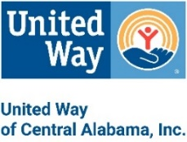

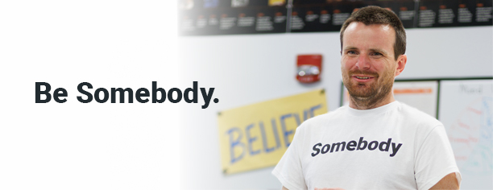
[Name],
Join [Company Name or Department or Group Name] as we support United Way of Central Alabama’s Annual Campaign. We will be hosting [an employee or a leadership] meeting on [date].
Meeting Details:
- Date:
- Time:
- Location or virtual meeting link:
Additional Information:
- Volunteer opportunity
- Celebration date
- Please remember that your United Way pledge is due by [date].
When you support United Way of Central Alabama, you are Somebody who’s part of the solution. Your support directly impacts thousands of individuals and families who need our help every day.
Be Somebody who makes a difference in people’s lives and makes this a better community for us all. Give to United Way of Central Alabama.

Thank you,
[Name]

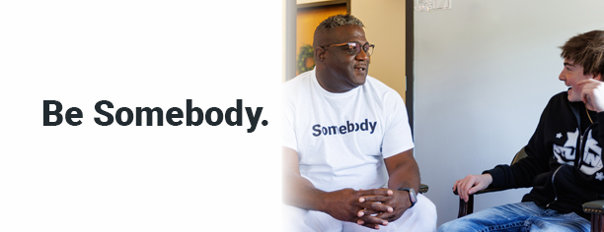
[Name],
We hope you plan to join us in supporting United Way of Central Alabama by pledging to our annual campaign. By doing so, you’ll give hope to our neighbors experiencing need throughout our community.
We understand, however, that making a financial contribution might be challenging.
For more ways to support beyond financial partnership, we invite you to connect with United Way by staying up to date on news and events, following them on social media or volunteering with United Way.
Whether you donate or make a gift of your time, you can Be Somebody who makes a difference in people’s lives and makes our community better for us all.
Thank you for thoughtful consideration of supporting United Way of Central Alabama.
[Name]

[Name],
Our United Way Campaign is coming to a close. We’d love for you to be a part of our effort to give hope and change lives. We’re asking you to Be Somebody who makes a difference in countless peoples’ lives and across our community as a whole.
When you support United Way of Central Alabama, you directly impact someone in our community by answering their most critical needs. It’s through the combined power of every single donor – every Somebody out there – that United Way can help so many people in so many ways.
So won’t you join us and Be Somebody who steps up to help create a brighter future for us all?
Thank you,
[Name]

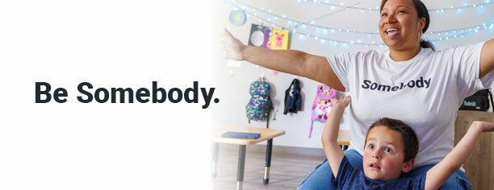

[Name],
Thank you for your pledge to our United Way 2024 annual campaign!
By supporting United Way, you’re not just donating; you’re becoming Somebody who cares, Somebody who steps up and Somebody who helps create a brighter future for Central Alabama.
You can keep track of progress by signing up for United Way’s newsletter and find meaningful volunteer opportunities for you and your family by joining INVOLVE.
Thank you for choosing to Be Somebody who makes a difference in people’s lives and makes this a better community for us all.
[Name]

