2021 Campaign Email Templates

Introduction Email

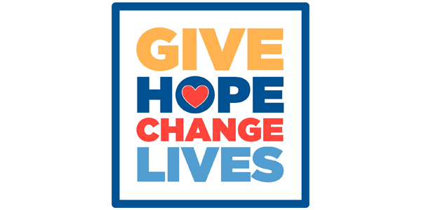
[Name],
We can all be thankful that our community is on the road to recovery. As much as we would like to put the pandemic and disastrous tornadoes of the past year completely behind us, many are still struggling. That’s why we’re asking you to join us in supporting United Way of Central Alabama (UWCA).
United Way was built for times like these. In addition to advancing the health, education and financial stability of people in six counties, UWCA is the community’s safety net when no other single organization can coordinate and deliver help – and hope - in so many ways, especially during times of crisis.
You will soon receive an email announcing United Way of Central Alabama’s annual campaign. Your gift will fund vital United Way programs and partner agencies that focus on helping those with critical needs and, in doing so, will make our entire community stronger and more resilient.
Let’s unite to give hope and change lives for the better.
[Name]

Kickoff Announcement
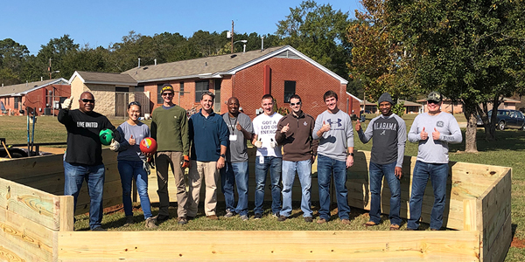
[Name],
Today we’re kicking off the United Way of Central Alabama (UWCA) annual campaign with the theme: Give Hope. Change Lives.
When you pledge to UWCA, you give hope to people in need throughout our community – people from all walks of life, many of whom would not ordinarily need help were it not for the challenges from the past year.
In 2020, UWCA programs:
- Helped 79,138 people receive healthcare-related services.
- Prepared 2,252 tax returns free of charge for working families.
- Helped 388 children receive virtual school support.
- Helped 73 veterans find stable housing.
To help meet the needs of the COVID-19 crisis, UWCA programs:
- Served 670,661 meals through Meals on Wheels and the Senior Nutrition Program.
- Assisted 54,317 callers through the 2-1-1 Call Center.
- Distributed $2,151,597 in grants from the Community Crisis Fund to support feeding programs, emergency assistance and distressed non-profits.
The past year was truly devastating for many. By supporting United Way of Central Alabama, you can help make the road to recovery smoother for us all. Now’s the perfect time to make your pledge.
Last year, our United Way campaign raised [$X,XXX]. We are striving to reach a goal of [$X] this year. Please help us meet our goal by completing your pledge by [date].
Let’s unite to give hope and change lives for the better.

[Name]

Campaign Details
[Name],
Join [Company Name or Department or Group Name] as we support United Way of Central Alabama’s Annual Campaign. We will be hosting [an employee or a leadership] meeting on [date].
Meeting Specifics:
Date
Time
Location or virtual meeting link

Additional Information:
Volunteer opportunity
Celebration date

Please remember that your United Way pledge is due by [date].
Let’s unite to give hope and change lives for the better.
Thank you,
[Name]

Donate and Other Ways to Get Involved
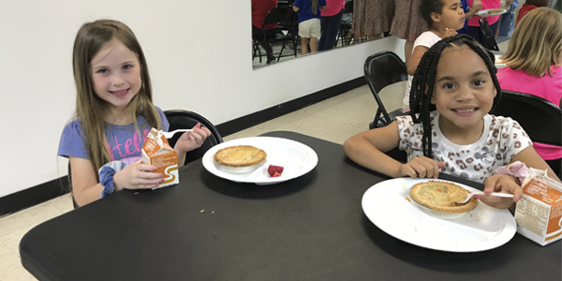
[Name],
We hope you are planning to join us in supporting United Way of Central Alabama (UWCA) by pledging to our annual campaign. When you do, you’ll give hope to people in need throughout our community. We understand, however, that making a financial contribution might be challenging.
If you’d like to support UWCA’s work in some other way, we invite you to connect with United Way by staying up to date on news and events, following them on social media or volunteering with one of United Way’s vital community programs or partner agencies.
Let’s unite to give hope and change lives for the better.
[Name]
Ninety-two cents of every dollar given to United Way is invested directly into programs and services in Blount, Chilton, Jefferson, Shelby, St. Clair and Walker counties.

Wrap Up Notification
[Name],
Our United Way Campaign is coming to a close. We’d love for you to be a part of giving hope to, and changing the lives of, our neighbors in need.
Throughout the past year, United Way of Central Alabama (UWCA) and its partner agencies have worked tirelessly to help individuals, families and distressed nonprofits with vital needs, such as food, support for virtual learning and funding for mental health services. And that’s in addition to UWCA’s ongoing work to advance people’s health, education and financial stability throughout the six-county area.
United Way was built for times like these.
UWCA is the community’s safety net when no other single organization can coordinate and deliver help – and hope – in so many ways. Won’t you help us make the road to recovery easier for those in need?
Let’s unite to give hope and change lives for the better.
[Name]

Thank You
[Name],
Thank you for your pledge to United Way! While the road to recovery from the past year remains challenging, you are giving hope and changing lives for the better throughout Central Alabama.
As our community regains a sense of normality, you can keep track of progress by signing up for United Way’s newsletter, or find meaningful volunteer opportunities for you and your family by joining INVOLVE.
Thank you for supporting United Way of Central Alabama and helping build a stronger community for us all.
To live better, we must LIVE UNITED.

