2022 Campaign Email Templates

Introduction Email

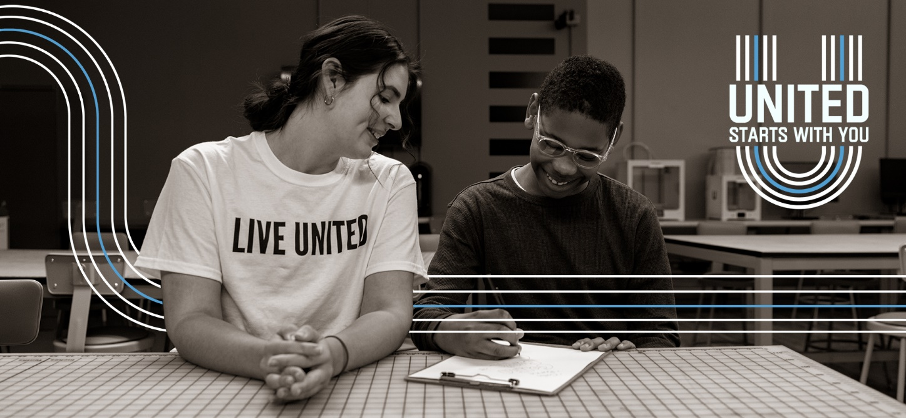

[Name],
We want everyone in our community to have the resources to thrive, not just survive. We are partnering with United Way of Central Alabama to uplift those in need.
For almost 100 years, United Way has helped families put food on the table, assisted people experiencing homelessness and offered relief to those in crisis. United Way is there for everyone in every stage of life.
You will soon receive an email announcing United Way of Central Alabama’s annual campaign. Your gift will fund vital United Way programs and partner agencies that focus on helping those with critical needs and, in doing so, will make our entire community stronger and more resilient.
United, we can make life better for everyone. United starts with you.

[Name]
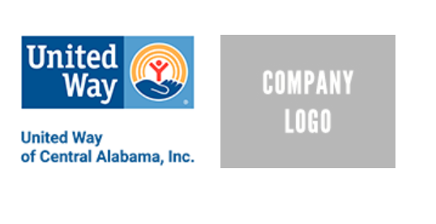

Kickoff Announcement
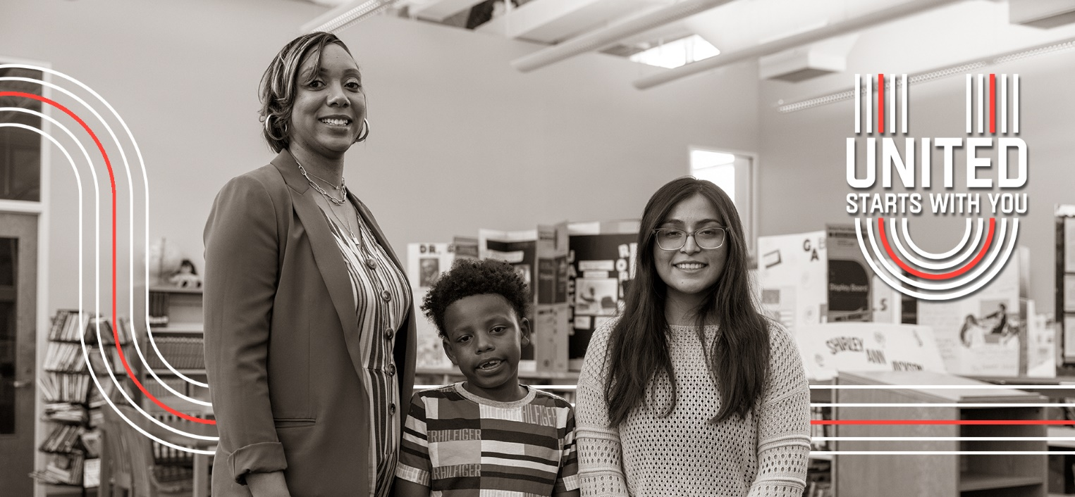
[Name],
Today we’re kicking off the United Way of Central Alabama (UWCA) annual campaign with the theme: United Starts with You.
When you pledge to UWCA, you give hope to people in need throughout our community – people from all walks of life, many of whom would not ordinarily need help were it not for recent challenges.
To help meet the needs of the COVID-19 crisis last year, UWCA programs:
- Served 426,298 meals through Meals on Wheels and the Senior Nutrition Program.
- Assisted 49,759 callers through the 2-1-1 Call Center.
- Helped 49,286 individuals receive services to address mental health, substance abuse and domestic violence.
- Helped family caregivers receive 6,146 hours of respite care.
- Distributed $2,515,005 in grants from the Community Crisis Fund to support feeding programs, emergency assistance and distressed nonprofits.
Last year, our United Way campaign raised [$X,XXX]. We are striving to reach a goal of [$X] this year. Please help us meet our goal by completing your pledge by [date].
Your contribution not only helps those with critical needs, but also makes our entire community stronger and more resilient.
United, we can make life better for everyone. United starts with you.
[Name]

Campaign Details
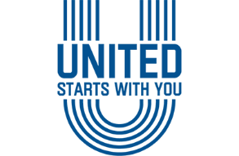
[Name],
Join [Company Name or Department or Group Name] as we support United Way of Central Alabama’s Annual Campaign. We will be hosting [an employee or a leadership] meeting on [date].
Meeting Specifics:
Date
Time
Location or virtual meeting link

Additional Information:
Volunteer opportunity
Celebration date

Please remember that your United Way pledge is due by [date].
United, we can make life better for everyone. United starts with you.
Thank you,
[Name]

Donate and Other Ways to Get Involved
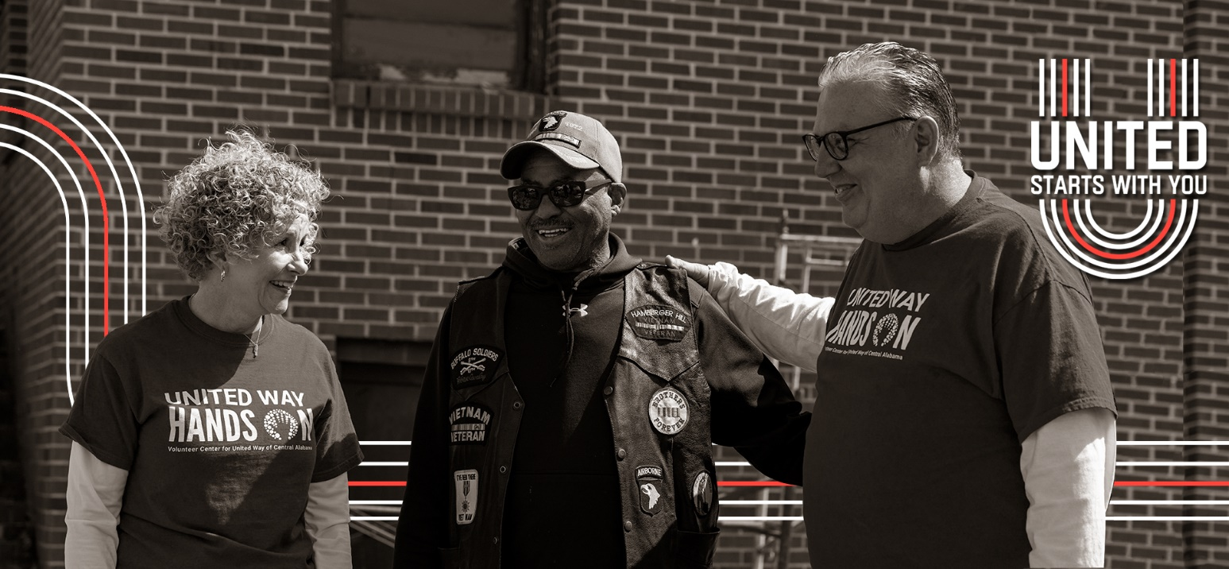
[Name],
We hope you plan to join us in supporting United Way of Central Alabama (UWCA) by pledging to our annual campaign. You’ll give hope to people in need throughout our community. We understand, however, that making a financial contribution might be challenging.
For more ways to support UWCA’s work, we invite you to connect with United Way by staying up to date on news and events, following them on social media or volunteering with one of United Way’s vital community programs or partner agencies.
United, we can make life better for everyone. United starts with you.
[Name]

Wrap Up Notification

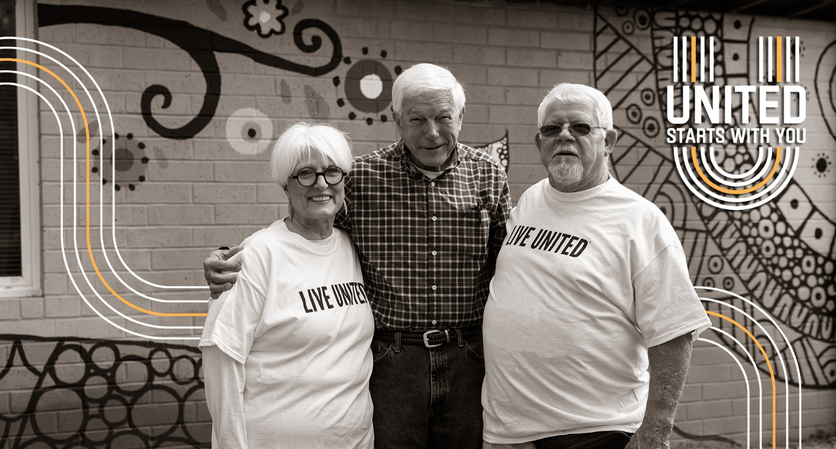
[Name],
Our United Way Campaign is coming to a close. We’d love for you to be a part of giving hope to, and changing the lives of, our neighbors.
Throughout the past year, United Way of Central Alabama (UWCA) and its partner agencies have worked tirelessly to help individuals, families and distressed nonprofits with vital needs, such as food, support for virtual learning and funding for mental health services. And that’s in addition to UWCA’s ongoing work to advance people’s health, education and financial stability throughout the six-county area.
United Way was built for times like these.
UWCA is the community’s safety net when no other single organization can coordinate and deliver help – and hope – in so many ways. Won’t you help us make the road to recovery easier for those in need?
We want to communicate, uplift and motivate those within our community, to bring their gifts together in a UNITED effort.
United, we can make life better for everyone. United starts with you.
[Name]

Thank You
[Name],
Thank you for your pledge to United Way! While the road to recovery from the past year remains challenging, you are changing lives for the better throughout Central Alabama.
As our community regains a sense of normality, you can keep track of progress by signing up for United Way’s newsletter, or find meaningful volunteer opportunities for you and your family by joining INVOLVE.
Thank you for supporting United Way of Central Alabama and helping build a stronger community for us all.
To live better, we must LIVE UNITED.

