2023 Campaign Email Templates

Introduction Email
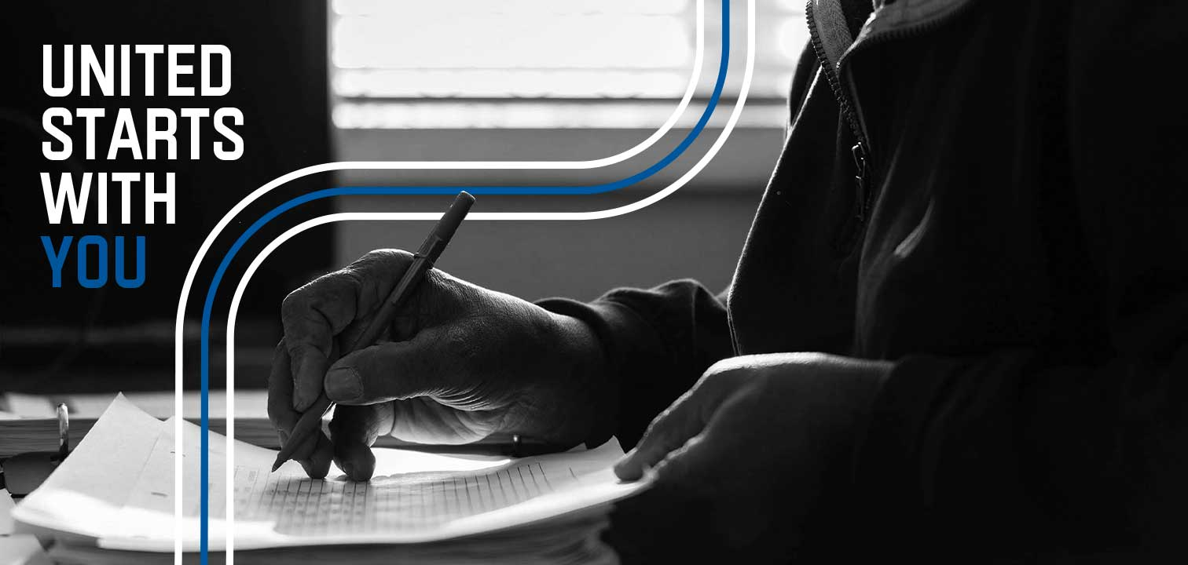

[Name],
Everyone in our community deserves access to the resources necessary not only to survive, but to thrive. We are partnering with United Way of Central Alabama to serve our neighbors’ most vital needs.
This is a special year to be involved as 2023 marks United Way’s 100th campaign. For a century, United Way has helped families put food on the table, assisted people experiencing homelessness and been a safety net in times of crisis.
You will soon receive an email announcing United Way of Central Alabama’s annual campaign. Your gift will fund vital United Way programs and partner agencies that aid in both short and long-term needs in our community, providing access to essential support now as well as in future crises.
United, we’ve supported our community for a century. Now, it’s time to kick off the next 100 years. United starts with you.

[Name]

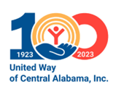

Kickoff Announcement
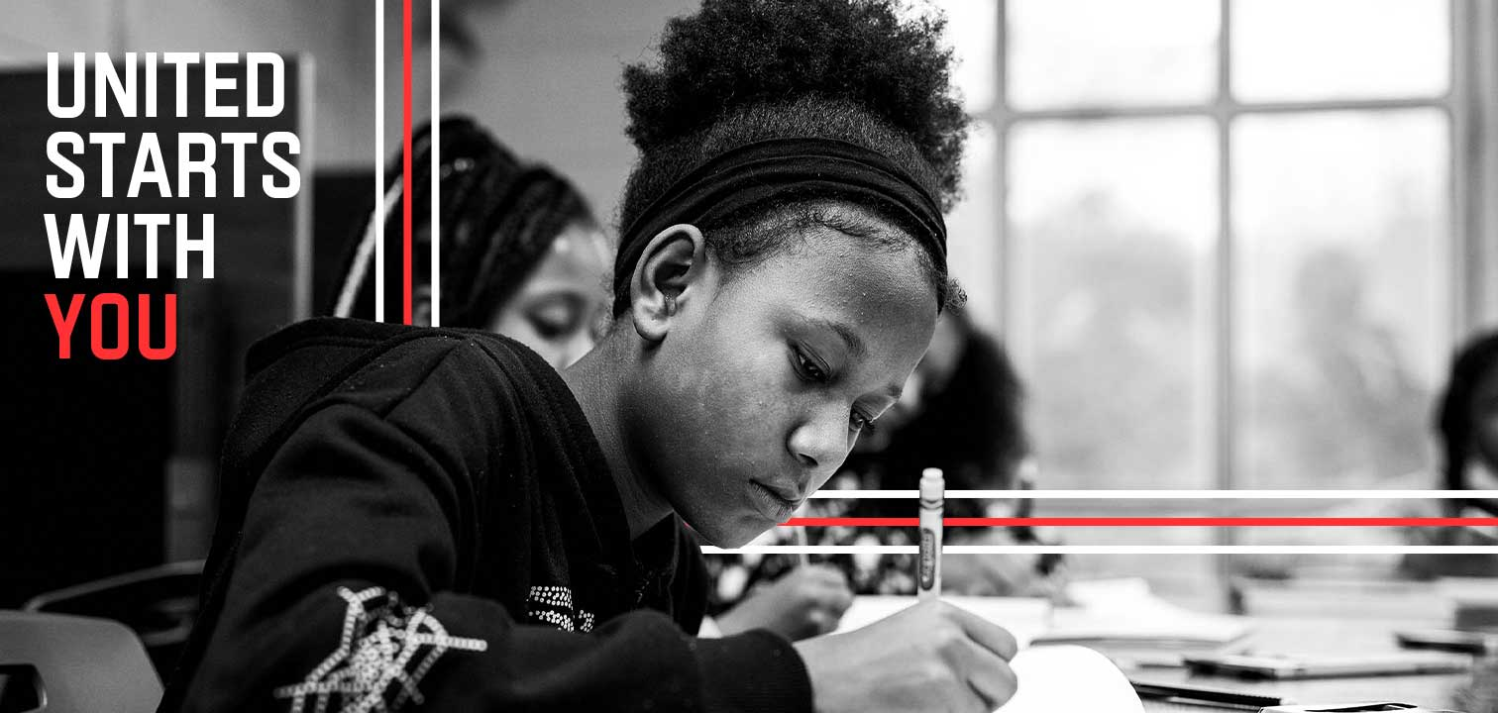
[Name],
Today we’re kicking off United Way of Central Alabama’s (UWCA’s) 100th annual campaign with the theme: United Starts with You.
The needs of our community have varied greatly during the last 100 years, but from the Great Depression to disastrous tornadoes and summers when students don’t have access to school lunches, there’s a common thread -- United Way is there. When you pledge to UWCA, you give hope to people experiencing need throughout our community – people who are our neighbors, many of whom would not ordinarily need help were it not for recent challenges.
UWCA’s strategic approach to aid is three-fold: financially supporting partner agencies; offering direct services to the community; and working to solve complex community problems through the Bold Goals Coalition.
To help meet the needs of our neighbors, UWCA:
- Addresses hunger and local food deserts.
- Invests in partners who provide mental health support to adults and children.
- Runs a housing-first assistance program for veterans.
- Supports quality early learning to improve school readiness and increase future graduation rates.
- And that’s just the beginning!
Last year, our United Way campaign raised [$X,XXX]. We are striving to reach a goal of [$X] this year. Please help us meet our goal by completing your pledge by [date]. Your contribution not only helps those with critical needs, but also makes our entire community stronger and more resilient.
United, we can make life better for everyone. United starts with you.
[Name]

Campaign Details
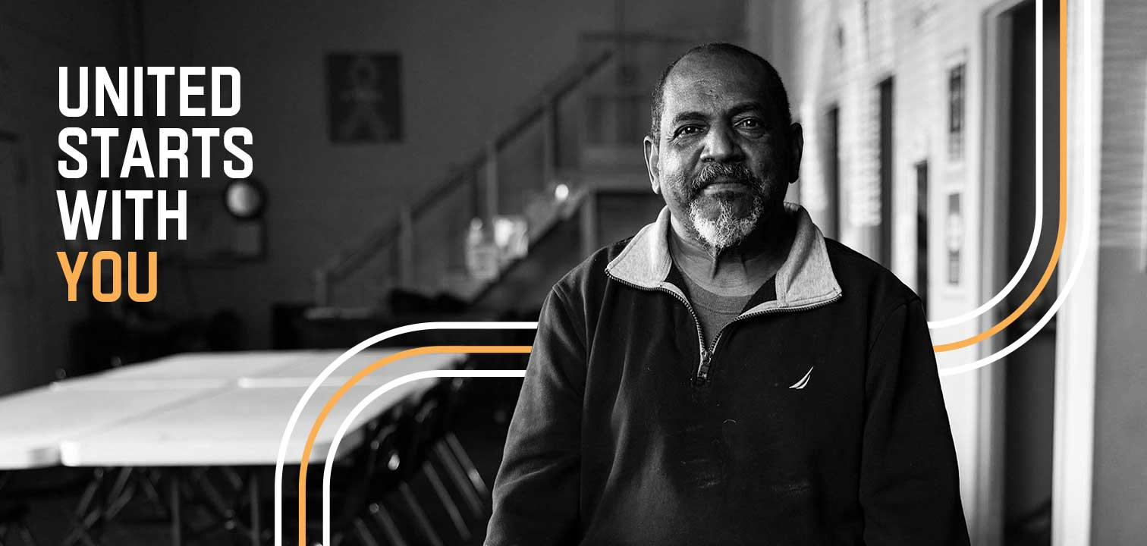
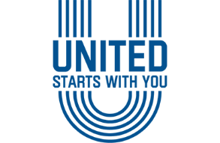
[Name],
Join [Company Name or Department or Group Name] as we support United Way of Central Alabama’s 100th Annual Campaign. We will be hosting [an employee or a leadership] meeting on [date].
Meeting Specifics:
Date
Time
Location or virtual meeting link
Additional Information:
Volunteer opportunity
Celebration date
Please remember that your United Way pledge is due by [date].
United, we can make life better for everyone. United starts with you.
Thank you,
[Name]

Donate and Other Ways to Get Involved

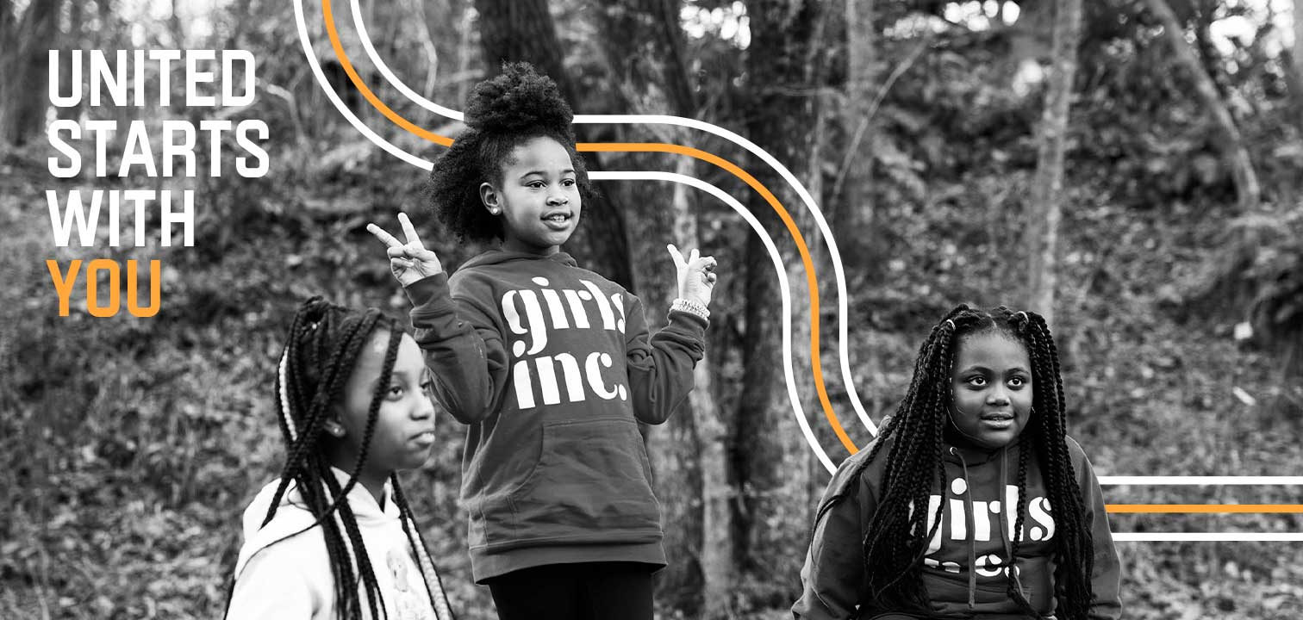
[Name],
We hope you plan to join us in supporting United Way of Central Alabama (UWCA) by pledging to our annual campaign. By doing so, you’ll give hope to our neighbors experiencing need throughout our community. We understand, however, that making a financial contribution might be challenging.
For more ways to support UWCA’s work beyond financial partnership, we invite you to connect with United Way by staying up to date on news and events, following them on social media or volunteering with one of United Way’s vital community programs or partner agencies. Whether by giving financially or through your time, you can make a difference.
United, we can make life better for everyone. United starts with you.
[Name]

Wrap Up Notification
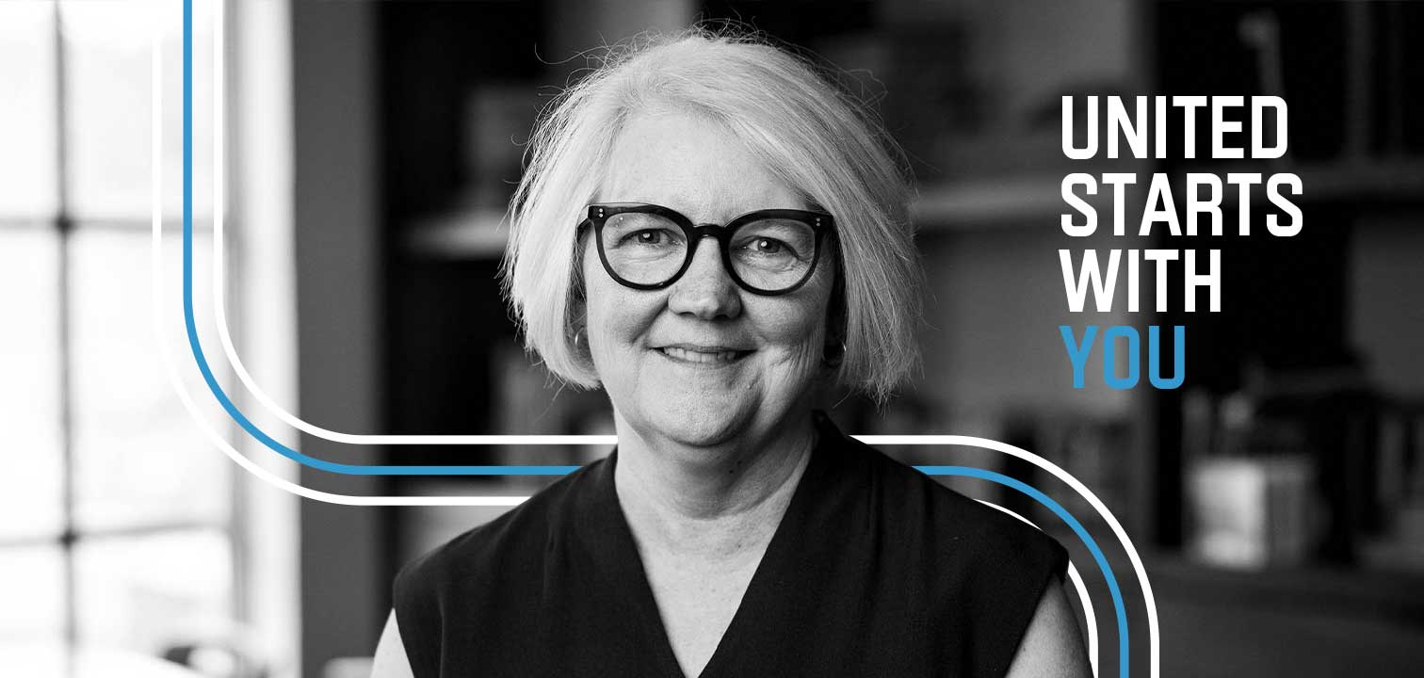
[Name],
Our United Way Campaign is coming to a close. We’d love for you to be a part of giving hope to, and changing the lives of, our neighbors.
Throughout the past year, United Way of Central Alabama (UWCA) and its partner agencies have worked tirelessly to help individuals, families and local nonprofits with vital needs, such as food, support for virtual learning and funding for mental health services. That is in addition to UWCA’s ongoing work to advance people’s health, education and financial stability throughout the six-county area.
United Way was built for times like these.
UWCA has been the community’s safety net for 100 years, a beacon of stability in an unstable time. By banding together, we can broaden the scope of help available far beyond what anyone could do alone. Won’t you help us make the road to recovery easier for those in need?
We want to communicate, uplift and motivate those within our community, to bring their gifts together in a UNITED effort.
United, we can make life better for everyone. United starts with you.
[Name]

Thank You

[Name],
Thank you for your pledge to United Way’s 100th campaign! You are changing lives for the better throughout Central Alabama.
As United Way kicks off its next 100 years of service, you can keep track of progress by signing up for United Way’s newsletter; or find meaningful volunteer opportunities for you and your family by joining INVOLVE.
Thank you for supporting United Way of Central Alabama and helping build a stronger community for us all.
To live better, we must LIVE UNITED.

